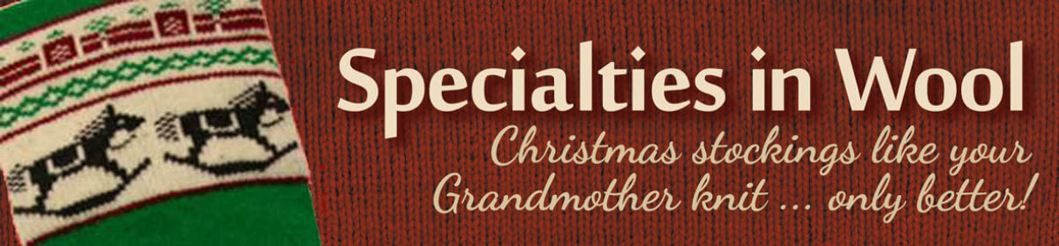
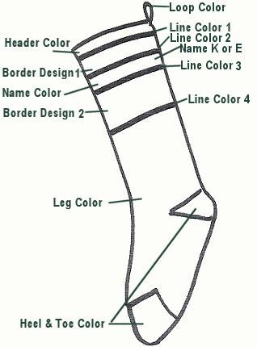
Custom Mix & Match Stockings
22″ long, 100% wool
Hemmed through bottom border
for snag-proofness.

Choose your colors and where they go.
Choose your border designs and personalization style

$66.50

Circle your choices below

1. Loop Color
Black Natural KellyGreen ForestGreen Navy Cranberry
2. Header Color
Black Natural KellyGreen ForestGreen Navy Cranberry
3. Line 1 Color
Black Natural KellyGreen ForestGreen Navy Cranberry
4. Upper Border Design
Sprig Holly Poinsettia Tree Tulip Snowflake
Bells Train Hearts Candies Sledder Horn
Reindeer Skates Presents Angels

5. Line 2 Color
Black Natural KellyGreen ForestGreen Navy Cranberry
6. Name Type
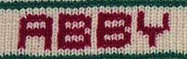  Knit in: up to 8 letters | 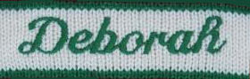  Embroidered  SCRIPT: up to 14 letters | Embroidered  CAIRO: up to 14 letters | 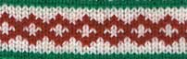  No Name

Name for Personalization:
7. Name Color
KellyGreen ForestGreen Navy Cranberry
8. Line 3 Color
Black Natural KellyGreen ForestGreen Navy Cranberry
9. Lower Border Design
Sprig Holly Poinsettia Tree Tulip Snowflake
Sleigh Bear Gingerbread Snowman Nutcracker Santa
Candycane Rocking Horse Angels Wreath Xmas Tree
10. Line 4 Color
Black Natural KellyGreen ForestGreen Navy Cranberry
11. Leg Color
Natural KellyGreen ForestGreen Navy Cranberry Black
12. Toe/Heel Color
Natural KellyGreen ForestGreen Navy Cranberry Black

If this is a gift, add your gift message here and we will hand write a card:

If you want to include other instructions for the knitter, please put that here:

Your information:
Billing:
Your name:
Street Address:
City, State, Zip:
Phone : ________________________ Email:
Shipping Address:
Name:
Street Address:
City, State, Zip:
Circle total | Each | + shipping (same address) | Total
1st Stocking | $66 | +$8.50 shipping | $ 74.50
2nd stocking | $66 |  | $ 140.50
3rd stocking | $66 | +$2 shipping | $ 208.50
Additional stockings | $66 | +$2 shipping each

Include a check payable to “Specialties in Wool”
Mail to: Specialties in Wool
187 Vt Rt 12
Montpelier, VT 05602

Questions: Call Marge (802) 229-9427

